27.73:
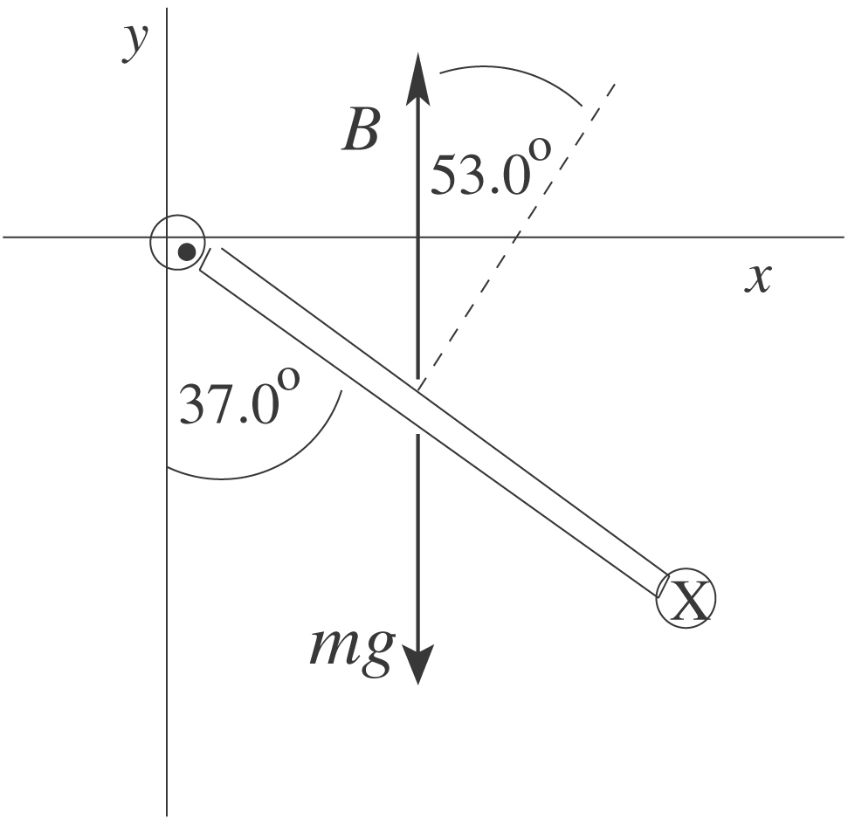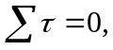
counterclockwise torques positive
